EE6325

VLSI Design

Project #1 Arbitrary Digital Design

**Arithmetic Logic Unit**

**with Speed boost**

Due Date: September 06, 2018

Submitted By,

Akshay Nandkumar Patil (anp170330)

Akash Anil Tadmare (aat171030)

Submission Date: September 06, 2018

**Arithmetic Logic Unit:**

Arithmetic and Logic Unit (ALU) is the heart of every computing system. It performs all arithmetic viz. addition, subtraction, division, multiplication and logical operations viz. AND, OR, NOT, XOR etc. and stores the result in a memory called accumulator. ALU also performs unsigned binary operations i.e. shift left, shift right, compare etc.

In this project we are using two 32 bit operands and 8 operations, i.e. 4 arithmetical and 4 logical operations. A 3 bit select line is used to select a particular operation and the ALU performs only the selected operation avoiding the other unnecessary operations. The operations include addition, subtraction, division, modulus, bitwise AND, bitwise OR, bitwise XOR, bitwise XNOR. Two operands use a separate 1:8 de-multiplexer as shown in the figure 1.0 to select a particular operation, selected operation is performed in the ALU and an 8:1 multiplexer is used to select the calculated result to be stored in the accumulator. Here the accumulator is a register which stores the result.

This design is scalable and a number of inputs can be added as well as size of operating bits can be increased for the higher levels of data. The number of operation options performed can be increased by increasing the select line length.

Limitation of design:

* This design does not perform some mathematical operations such as multiplication.

Scope for improvement:

* Code convertor can be added along with the operations to convert the binary operands into gray code, excess- 3 code, binary coded decimals etc.

We will work on the limitations and improvements in the later stages of semester as we progress with the project.

**Block Diagram:**

b4

b3

xnor

xor

or

and

mod

div

sub

add

s0

s1

s2

s0

b2

b0

s0

s1

s2

b7

b6

b5

b1

s17

s2

a2

a5

a6

a7

a0

a3

a4

1x8 DMUX

1x8 DMUX

Select lines

Select lines

8x1 MUX

Select lines

Addition

a0+b0

Subtraction

a1-b1

Division

a2/b2

Modulus

a3%b3

AND

a AND b

OR

a OR b

input1

input2

mux

mux

out

EX-OR

a XOR b

a

EX-NOR

a XNOR b

32 bit

D Flip-Flop

a1

**Figure 1.0 Block diagram of Arithmetic and Logic Unit (ALU)**

reset

clock

**Figure 2 Connection of Testbench and ALU module**

32bit input1

ALU under Test

Source Test Inputs

out

32bit input2

3bit select line

**Source Code:**

module boosted_alu(input1,input2,select,clock,reset,out,mux,adn,sub,div,remainder,andd,orr,exxor,exxnor);

input [31:0]input1,input2; //Two input numbers

input clock,reset; //clock and reset for flipflop circuit

input [2:0]select; //select input to determine one of the eight operations

output [32:0]out,mux,adn,sub;

/* out is a final output

mux is an main output available at the output of multiplexer connected to the input of flipflop

adn is the addition output with carryout as MSB

sub is the subtraction output with borrow as MSB */

output [31:0]div,remainder,andd,orr,exxor,exxnor;

/*div is division of input numbers

remainder is remainder after division of input numbers*/

reg [31:0]a1,a2,a3,a4,a5,a6,a7,a0,b1,b2,b3,b4,b5,b6,b7,b0;

/*a0 through a7 is input1 at the output of demux1

b0 through b7 is input2 at the output of demux2*/

reg [32:0]out,mux;

reg [31:0]div,remainder,andd,orr,exxor,exxnor;

reg [32:0]adn,sub;

//1:8 demux1 code for input1

always@(*)

begin

case (select)

//input is sent to selected output line and other lines are made don’t care to avoid latches

3'b000 :begin a0<=input1; a1<=32'bxxxxxxxxxxxxxxxxxxxxxxxxxxxxxxxx; a2<=32'bxxxxxxxxxxxxxxxxxxxxxxxxxxxxxxxx; a3<=32'bxxxxxxxxxxxxxxxxxxxxxxxxxxxxxxxx; a4<=32'bxxxxxxxxxxxxxxxxxxxxxxxxxxxxxxxx; a5<=32'bxxxxxxxxxxxxxxxxxxxxxxxxxxxxxxxx; a6<=32'bxxxxxxxxxxxxxxxxxxxxxxxxxxxxxxxx; a7<=32'bxxxxxxxxxxxxxxxxxxxxxxxxxxxxxxxx;

end

3'b001 :begin a1<=input1;

a0<=32'bxxxxxxxxxxxxxxxxxxxxxxxxxxxxxxxx; a2<=32'bxxxxxxxxxxxxxxxxxxxxxxxxxxxxxxxx; a3<=32'bxxxxxxxxxxxxxxxxxxxxxxxxxxxxxxxx; a4<=32'bxxxxxxxxxxxxxxxxxxxxxxxxxxxxxxxx; a5<=32'bxxxxxxxxxxxxxxxxxxxxxxxxxxxxxxxx;

a6<=32'bxxxxxxxxxxxxxxxxxxxxxxxxxxxxxxxx; a7<=32'bxxxxxxxxxxxxxxxxxxxxxxxxxxxxxxxx;

end

3'b010 :begin a2<=input1; a0<=32'bxxxxxxxxxxxxxxxxxxxxxxxxxxxxxxxx; a1<=32'bxxxxxxxxxxxxxxxxxxxxxxxxxxxxxxxx; a3<=32'bxxxxxxxxxxxxxxxxxxxxxxxxxxxxxxxx; a4<=32'bxxxxxxxxxxxxxxxxxxxxxxxxxxxxxxxx; a5<=32'bxxxxxxxxxxxxxxxxxxxxxxxxxxxxxxxx; a6<=32'bxxxxxxxxxxxxxxxxxxxxxxxxxxxxxxxx; a7<=32'bxxxxxxxxxxxxxxxxxxxxxxxxxxxxxxxx;

end

3'b011 :begin a3<=input1; a0<=32'bxxxxxxxxxxxxxxxxxxxxxxxxxxxxxxxx; a1<=32'bxxxxxxxxxxxxxxxxxxxxxxxxxxxxxxxx; a2<=32'bxxxxxxxxxxxxxxxxxxxxxxxxxxxxxxxx; a4<=32'bxxxxxxxxxxxxxxxxxxxxxxxxxxxxxxxx; a5<=32'bxxxxxxxxxxxxxxxxxxxxxxxxxxxxxxxx; a6<=32'bxxxxxxxxxxxxxxxxxxxxxxxxxxxxxxxx; a7<=32'bxxxxxxxxxxxxxxxxxxxxxxxxxxxxxxxx;

end

3'b100 :begin a4<=input1; a0<=32'bxxxxxxxxxxxxxxxxxxxxxxxxxxxxxxxx; a1<=32'bxxxxxxxxxxxxxxxxxxxxxxxxxxxxxxxx; a2<=32'bxxxxxxxxxxxxxxxxxxxxxxxxxxxxxxxx; a3<=32'bxxxxxxxxxxxxxxxxxxxxxxxxxxxxxxxx; a5<=32'bxxxxxxxxxxxxxxxxxxxxxxxxxxxxxxxx; a6<=32'bxxxxxxxxxxxxxxxxxxxxxxxxxxxxxxxx; a7<=32'bxxxxxxxxxxxxxxxxxxxxxxxxxxxxxxxx;

end

3'b101 :begin a5<=input1; a0<=32'bxxxxxxxxxxxxxxxxxxxxxxxxxxxxxxxx; a1<=32'bxxxxxxxxxxxxxxxxxxxxxxxxxxxxxxxx;

a2<=32'bxxxxxxxxxxxxxxxxxxxxxxxxxxxxxxxx; a3<=32'bxxxxxxxxxxxxxxxxxxxxxxxxxxxxxxxx; a4<=32'bxxxxxxxxxxxxxxxxxxxxxxxxxxxxxxxx; a6<=32'bxxxxxxxxxxxxxxxxxxxxxxxxxxxxxxxx; a7<=32'bxxxxxxxxxxxxxxxxxxxxxxxxxxxxxxxx;

end

3'b110 :begin a6<=input1; a0<=32'bxxxxxxxxxxxxxxxxxxxxxxxxxxxxxxxx; a1<=32'bxxxxxxxxxxxxxxxxxxxxxxxxxxxxxxxx; a2<=32'bxxxxxxxxxxxxxxxxxxxxxxxxxxxxxxxx; a3<=32'bxxxxxxxxxxxxxxxxxxxxxxxxxxxxxxxx; a4<=32'bxxxxxxxxxxxxxxxxxxxxxxxxxxxxxxxx;

a5<=32'bxxxxxxxxxxxxxxxxxxxxxxxxxxxxxxxx; a7<=32'bxxxxxxxxxxxxxxxxxxxxxxxxxxxxxxxx;

end

3'b111 :begin a7<=input1;

a0<=32'bxxxxxxxxxxxxxxxxxxxxxxxxxxxxxxxx; a1<=32'bxxxxxxxxxxxxxxxxxxxxxxxxxxxxxxxx; a2<=32'bxxxxxxxxxxxxxxxxxxxxxxxxxxxxxxxx; a3<=32'bxxxxxxxxxxxxxxxxxxxxxxxxxxxxxxxx; a4<=32'bxxxxxxxxxxxxxxxxxxxxxxxxxxxxxxxx; a5<=32'bxxxxxxxxxxxxxxxxxxxxxxxxxxxxxxxx; a6<=32'bxxxxxxxxxxxxxxxxxxxxxxxxxxxxxxxx;

end

default $display("select input is wrong");

endcase

end

//1:8 demux2 code for input2

always@(*)

begin

case (select)

//input is sent to selected output line and other lines are made don’t care to avoid latches

3'b000 :begin b0<=input2;

b1<=32'bxxxxxxxxxxxxxxxxxxxxxxxxxxxxxxxx;

b2<=32'bxxxxxxxxxxxxxxxxxxxxxxxxxxxxxxxx;

b3<=32'bxxxxxxxxxxxxxxxxxxxxxxxxxxxxxxxx;

b4<=32'bxxxxxxxxxxxxxxxxxxxxxxxxxxxxxxxx; b5<=32'bxxxxxxxxxxxxxxxxxxxxxxxxxxxxxxxx; b6<=32'bxxxxxxxxxxxxxxxxxxxxxxxxxxxxxxxx;

b7<=32'bxxxxxxxxxxxxxxxxxxxxxxxxxxxxxxxx;

end

3'b001 :begin b1<=input2; b0<=32'bxxxxxxxxxxxxxxxxxxxxxxxxxxxxxxxx; b2<=32'bxxxxxxxxxxxxxxxxxxxxxxxxxxxxxxxx;

b3<=32'bxxxxxxxxxxxxxxxxxxxxxxxxxxxxxxxx;

b4<=32'bxxxxxxxxxxxxxxxxxxxxxxxxxxxxxxxx;

b5<=32'bxxxxxxxxxxxxxxxxxxxxxxxxxxxxxxxx;

b6<=32'bxxxxxxxxxxxxxxxxxxxxxxxxxxxxxxxx;

b7<=32'bxxxxxxxxxxxxxxxxxxxxxxxxxxxxxxxx;

end

3'b010 :begin b2<=input2;

b0<=32'bxxxxxxxxxxxxxxxxxxxxxxxxxxxxxxxx;

b1<=32'bxxxxxxxxxxxxxxxxxxxxxxxxxxxxxxxx;

b3<=32'bxxxxxxxxxxxxxxxxxxxxxxxxxxxxxxxx;

b4<=32'bxxxxxxxxxxxxxxxxxxxxxxxxxxxxxxxx;

b5<=32'bxxxxxxxxxxxxxxxxxxxxxxxxxxxxxxxx;

b6<=32'bxxxxxxxxxxxxxxxxxxxxxxxxxxxxxxxx;

b7<=32'bxxxxxxxxxxxxxxxxxxxxxxxxxxxxxxxx;

end

3'b011 :begin b3<=input2;

b0<=32'bxxxxxxxxxxxxxxxxxxxxxxxxxxxxxxxx;

b1<=32'bxxxxxxxxxxxxxxxxxxxxxxxxxxxxxxxx;

b2<=32'bxxxxxxxxxxxxxxxxxxxxxxxxxxxxxxxx;

b4<=32'bxxxxxxxxxxxxxxxxxxxxxxxxxxxxxxxx;

b5<=32'bxxxxxxxxxxxxxxxxxxxxxxxxxxxxxxxx;

b6<=32'bxxxxxxxxxxxxxxxxxxxxxxxxxxxxxxxx;

b7<=32'bxxxxxxxxxxxxxxxxxxxxxxxxxxxxxxxx;

end

3'b100 :begin b4<=input2;

b0<=32'bxxxxxxxxxxxxxxxxxxxxxxxxxxxxxxxx;

b1<=32'bxxxxxxxxxxxxxxxxxxxxxxxxxxxxxxxx;

b2<=32'bxxxxxxxxxxxxxxxxxxxxxxxxxxxxxxxx;

b3<=32'bxxxxxxxxxxxxxxxxxxxxxxxxxxxxxxxx;

b5<=32'bxxxxxxxxxxxxxxxxxxxxxxxxxxxxxxxx;

b6<=32'bxxxxxxxxxxxxxxxxxxxxxxxxxxxxxxxx;

b7<=32'bxxxxxxxxxxxxxxxxxxxxxxxxxxxxxxxx;

end

3'b101 :begin b5<=input2;

b0<=32'bxxxxxxxxxxxxxxxxxxxxxxxxxxxxxxxx;

b1<=32'bxxxxxxxxxxxxxxxxxxxxxxxxxxxxxxxx;

b2<=32'bxxxxxxxxxxxxxxxxxxxxxxxxxxxxxxxx;

b3<=32'bxxxxxxxxxxxxxxxxxxxxxxxxxxxxxxxx;

b4<=32'bxxxxxxxxxxxxxxxxxxxxxxxxxxxxxxxx;

b6<=32'bxxxxxxxxxxxxxxxxxxxxxxxxxxxxxxxx;

b7<=32'bxxxxxxxxxxxxxxxxxxxxxxxxxxxxxxxx;

end

3'b110 :begin b6<=input2;

b0<=32'bxxxxxxxxxxxxxxxxxxxxxxxxxxxxxxxx;

b1<=32'bxxxxxxxxxxxxxxxxxxxxxxxxxxxxxxxx;

b2<=32'bxxxxxxxxxxxxxxxxxxxxxxxxxxxxxxxx;

b3<=32'bxxxxxxxxxxxxxxxxxxxxxxxxxxxxxxxx;

b4<=32'bxxxxxxxxxxxxxxxxxxxxxxxxxxxxxxxx;

b5<=32'bxxxxxxxxxxxxxxxxxxxxxxxxxxxxxxxx;

b7<=32'bxxxxxxxxxxxxxxxxxxxxxxxxxxxxxxxx;

end

3'b111 :begin b7<=input2;

b0<=32'bxxxxxxxxxxxxxxxxxxxxxxxxxxxxxxxx;

b1<=32'bxxxxxxxxxxxxxxxxxxxxxxxxxxxxxxxx;

b2<=32'bxxxxxxxxxxxxxxxxxxxxxxxxxxxxxxxx;

b3<=32'bxxxxxxxxxxxxxxxxxxxxxxxxxxxxxxxx;

b4<=32'bxxxxxxxxxxxxxxxxxxxxxxxxxxxxxxxx;

b5<=32'bxxxxxxxxxxxxxxxxxxxxxxxxxxxxxxxx;

b6<=32'bxxxxxxxxxxxxxxxxxxxxxxxxxxxxxxxx;

end

default $display("select input is wrong");

endcase

end

//code for ALU

always@(*) //Arithmatic and Logical operations

begin

//ARITHMATIC

adn=a0+b0; //addtion module

sub=a1-b1; //subtraction module

div=a2/b2; //input1 is divided by input2

remainder=a3%b3; //remainder after input1 is divided by input2

//LOGICAL

andd=a4&b4; //input1 AND input2

orr=a5|b5; //input1 OR input2

exxor=a6^b6; //input1 XOR input2

exxnor=a7^~b7; //input1 XNOR input2

end

//8:1 mux code for forwarding the output of selected operation

always@(*)

begin

case (select)

3'b000 : mux<=adn;

3'b001 : mux<=sub;

3'b010 : mux<=div;

3'b011 : mux<=remainder;

3'b100 : mux<=andd;

3'b101 : mux<=orr;

3'b110 : mux<=exxor;

3'b111 : mux<=exxnor;

default $display("select input is wrong");

endcase

end

//Flip-flop code mudule

always@(posedge clock)

begin

if (reset) begin

out<=0;

end

else begin

out<=mux;

end

end

endmodule

**Testbench:**

module boosted_alu_tb;

// Inputs

reg [31:0] input1;

reg [31:0] input2;

reg [2:0] select;

reg clock;

reg reset;

// Outputs

wire [32:0] out;

wire [32:0] mux;

wire [32:0] adn;

wire [32:0] sub;

wire [31:0] div;

wire [31:0] remainder;

wire [31:0] andd;

wire [31:0] orr;

wire [31:0] exxor;

wire [31:0] exxnor;

// Instantiate the Unit Under Test (UUT)

boosted_alu uut (

.input1(input1),

.input2(input2),

.select(select),

.clock(clock),

.reset(reset),

.out(out),

.mux(mux),

.adn(adn),

.sub(sub),

.div(div),

.remainder(remainder),

.andd(andd),

.orr(orr),

.exxor(exxor),

.exxnor(exxnor)

);

initial begin

// Initialize Inputs

input1 = 32'b00001000111101010011010110000110;

input2 = 32'b00001000111101010011010110000001;

reset = 0;

clock = 1;

select = 3'b000; //addition

#20

select = 3'b001; //subtraction

#20

select = 3'b010; //division

#20

select = 3'b011; //remainder

#20

select = 3'b100; //bitwise AND

#20

select = 3'b101; //bitwise OR

#20

select = 3'b110; //bitwise ExOR

#20

select = 3'b111; //bitwise ExNOR

end

//clock

always begin

#5 clock=~clock; //invert after every 5ns

end

endmodule

**Simulation results:**

The below output waveforms shows that the ALU is calculating only one operation which is selected by the input lines. Other operation are ignored and not calculated even internally.

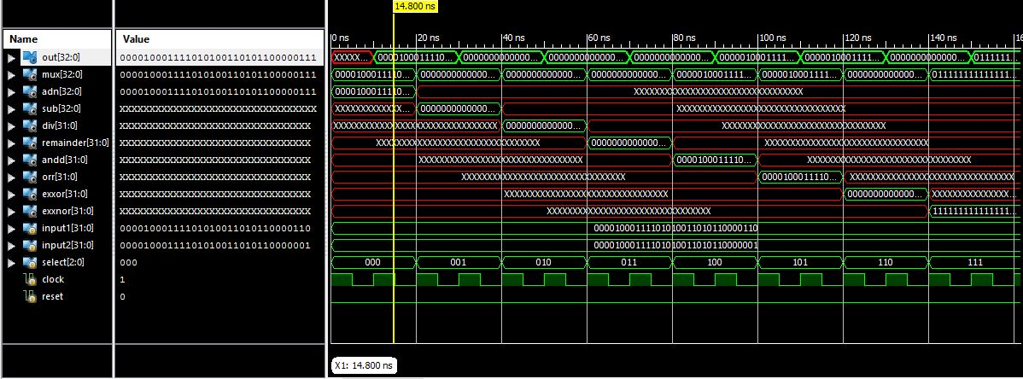

Figure : Addition

input1 = 00001000111101010011010110000110

input2 = 00001000111101010011010110000001

out = 000010001111010100110101100000111

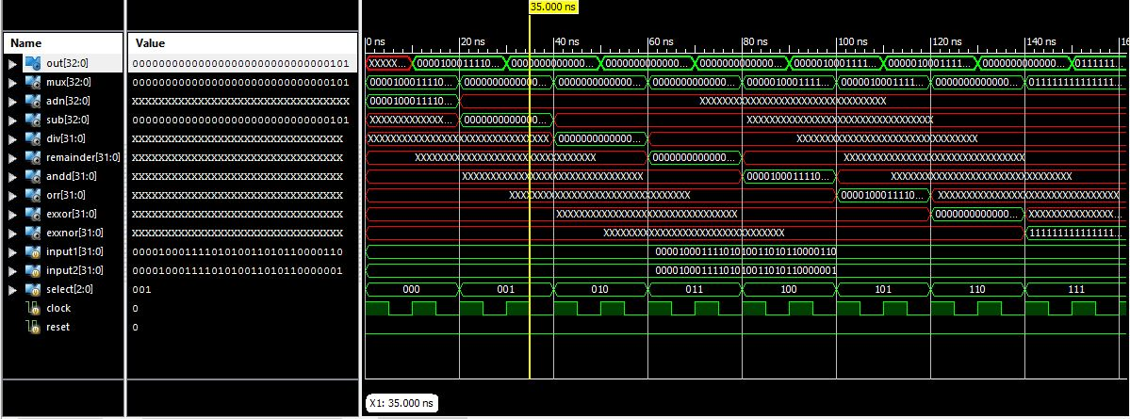

Figure : Subtraction

input1 = 00001000111101010011010110000110

input2 = 00001000111101010011010110000001

out = 00000000000000000000000000000101

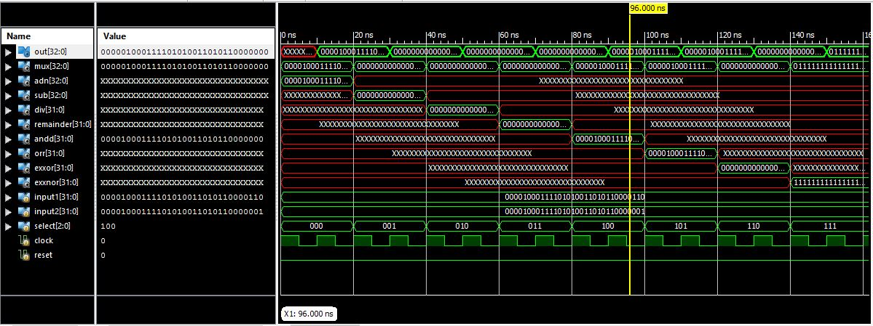

Figure : Bitwise AND

input1 = 00001000111101010011010110000110

input2 = 00001000111101010011010110000001

out = 00001000111101010011010110000000

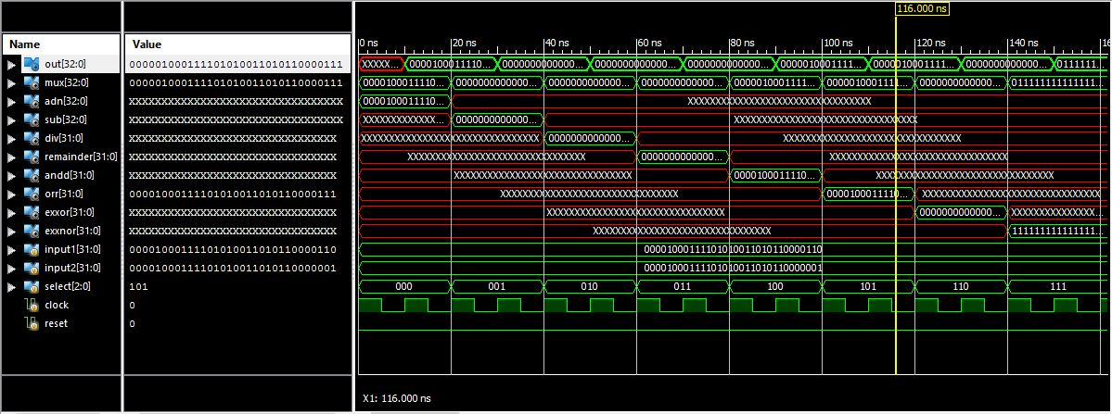

Figure : Bitwise OR

input1 = 00001000111101010011010110000110

input2 = 00001000111101010011010110000001

out = 00001000111101010011010110000111